History is focused on six key concepts: causation, consequence, change, continuity, significance and perspectives. Building your understanding of these key concepts is vital to progression in history.  In their efforts to place thinking at the centre of historical understanding, researchers in history education have highlighted the role that concepts such as these play in helping to shape our thinking about history. These concepts help students to think critically about historical issues; helping students to identify and solve problems, make decisions, and form judgments about past claims, actors and issues.  ​Explore the relevant sections below to find out more about each key concept and how you can improve your understanding of each one: |  | 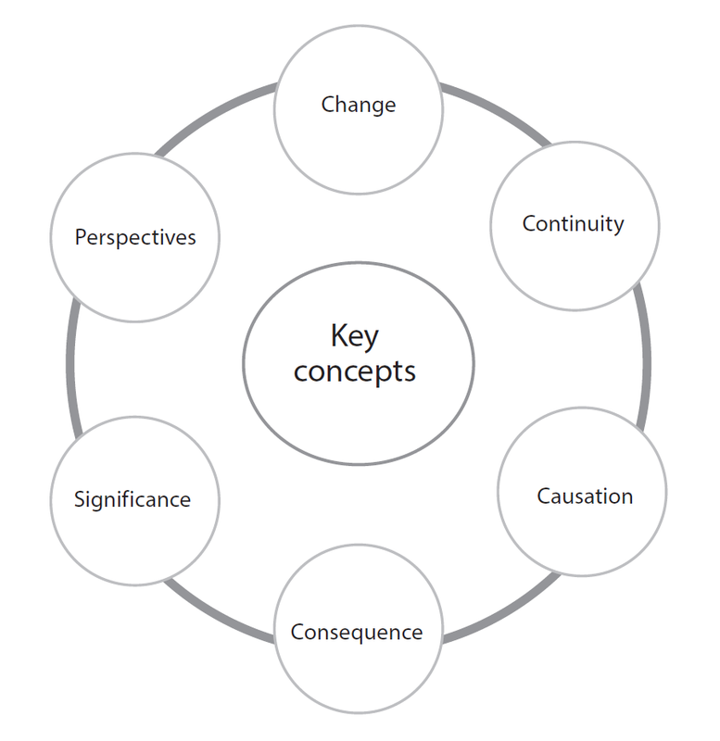
​Cause | ​Effective historical thinkers recognize that many claims made about the past seek to more thoroughly explain and understand how a certain set of circumstances originated. Deep historical understanding is demonstrated where students recognize that most historical events are caused by an interplay of diverse and multiple causes that require students to make evidence-based judgments about which causes were more important or significant, or which causes were within the scope of individuals to direct and which were not.
​Consequence | ​History is the understanding of how forces in the past have shaped future people and societies. Students demonstrate competency as historical thinkers where they understand and can explain how significant events and people have had both short-term and long-lasting effects. Students use evidence and interpretations of those people and events to make comparisons between different points in time, and to make judgments about the extent to which those forces produced long-lasting and important consequences.
​Change | ​The study of history involves investigation of the extent to which people and events bring about change. Discussion of the concept of change can encourage sophisticated discussions such as encouraging students to think about, and look for, change where some claim none exists, or using evidence to challenge orthodox theories and assumptions about people and events that it is claimed led to significant change. Students’ questions and judgments about historical change should be based on deep understanding of content and on comparison of the situation before and after the events under examination.
Continuity​​ | ​While historical study often focuses on moments of significant change, students should also be aware that some change is slow, and that throughout history there is also significant continuity. Students can demonstrate deep historical knowledge and understanding by, for  example, showing awareness that there are times when there has been considerable continuity in the midst of great historical change. Alternatively, students may question and assess whether a change in political leadership, for example, brought about a change in foreign policy, or whether it was more accurately mirroring policies of previous governments.
Perspectives | ​IB students should be aware of how history is sometimes used or abused to retell and promote a grand narrative of history, a narrowly focused national mythology that ignores other perspectives, or to elevate a single perspective to a position of predominance. Students are encouraged to challenge and critique multiple perspectives of the past, and to compare them and corroborate them with historical evidence. Students should recognize that for every event recorded in the past, there may be multiple contrasting or differing perspectives. Using primary-source accounts and historians’ interpretations, students may also investigate and compare how people, including specific groups such as minorities or women, may have experienced events differently in the past. In this way there are particularly strong links between exploring multiple perspectives and the development of international-mindedness.
Significance | ​History is not simply the record of all events that have happened in the past. Instead, history is the record that has been preserved through evidence or traces of the past, and/or the aspects that someone has consciously decided to record and communicate. Students should be encouraged to ask questions about why something may have been recorded or included in a historical narrative. Similarly, they should be encouraged to think about who or what has been excluded from historical narratives, and for what reasons. Additionally, students’ questions should encourage them to think about, and assess, the relative importance of events, people, groups or developments, and whether the evidence supports the claims that others make about their significance.

